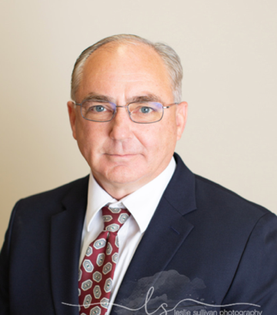

Blair Smith is the cofounder of the Viking SENSO Reunion and serves as the current Viking SENSO Reunion Chairman. Blair also serves on the Viking SENSO Association Board as the Secretary.

FAA Licenses: Airline Transport Pilot (ATP), Turbojet Flight Engineer (FE), Remote Pilot

For the past 27 years plus, Blair has been an Associate Professor for Embry-Riddle Aeronautical University (ERAU) where he has taught over 100 college courses at the undergraduate and graduate levels, both online, and in the classroom.

Blair retired from the United States Navy in 2000 after 22 years of service and subsequently became a pilot for Raytheon Travel Air and Delta Airlines. Blair early retired from Delta Airlines due to the events on 9-11. Following the Delta retirement, Blair worked for Booz Allen Hamilton at the United States Navy's Space and Naval Warfare Systems Command (SPAWAR) where he was assigned to operational test and experimentation. In 2005, Blair left SPAWAR to become the Program Manager of a team of 250 plus civilian patriots supporting the United States Air Force’s Global War on Terrorism (GWOT) efforts with their MQ-9 Reaper and MQ-1 Predator global operations. From 2017-2021, Blair supported the Nevada Institute for Autonomous Systems (NIAS) as the Executive Director and as Deputy Director of Air Operations. His work mainly revolved around supporting NASA’s and FAA’s efforts to develop an Unmanned Traffic Management (UTM) system as well as leading the NIAS Center of Excellence (COE).

Blair holds a bachelor’s degree, and a master’s degree in Organization Development from the University of San Francisco. He also attended the U.S. Navy's Post Graduate School in Monterrey, CA where he completed the curriculum for designation as an Aviation Safety Officer (ASO). He has logged over 5,000 flight hours while qualifying in Jets, Props, and Helicopters.

Blair is also a published author whose book “The Poems” is available on Amazon

[The Poems](https://www.amazon.com/s?k=blair+smith+the+poems&crid=3FO9TDLF0769G&sprefix=Blair+Smith%2Caps%2C250&ref=nb_sb_ss_i_1_11)