Robert Danial Wilcox

MARCH 19, 1947 – MARCH 5, 2023

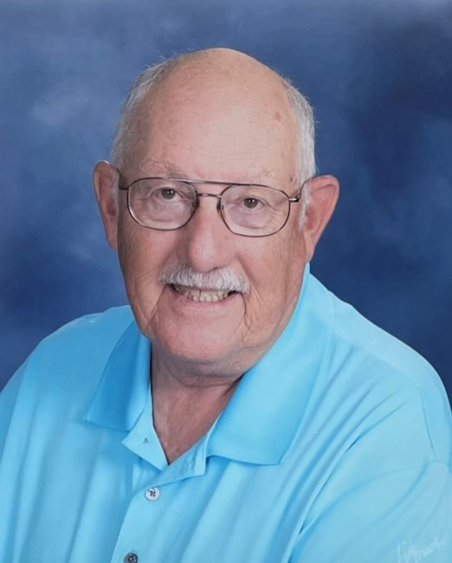

Robert D. Wilcox, a beloved husband, father, grandfather, great-grandfather, and retired Senior Chief Petty Officer of the United States Navy, passed away peacefully on March 5, 2023, in Florida. Robert, also known as Bob, was born in Altoona, PA in 1947.

Bob's love of country led him to enlist in the Navy at the young age of 17, and he served his country with distinction for 22 years. As an AWCS, Bob worked as a crew member on P-3s flying around the world. Bob was proud to serve and protect his country, and he instilled that pride in his family.

Bob was a man of many talents and interests. In addition to his service to his country, he was an accomplished square dance caller, sharing his love of square dancing with countless others. Bob was also an avid RV'er, traveling the country with his wife, Sally, and their beloved dogs. Together, they explored the highways and byways of America, forging memories that will last a lifetime.

Bob's greatest joy in life was his family. He was a devoted husband to Sally, his wife of 55 years, and a loving father to his daughters, Michelle (Chris) Tietz and Joanne (Wendell) Cantrell. He enjoyed being a grandfather to his seven grandchildren, Robert, Kayte, Dell, Wesley, Alexandrya, Katelynne, and Laird, and his great-grandchildren Stella and Wayland. He cherished every moment spent with them.

Bob will be remembered for his unwavering loyalty, kindness, infectious smile and love of trivia. His family and friends will greatly miss him, and his legacy will live on through the countless lives he touched during his time on this earth.

Per his wishes, Bob will be interned at Bushnell National Cemetery, Florida. In lieu of flowers, the family requests that donations be made to your local Animal Shelter or Rescue.