VS-22 Checkmates
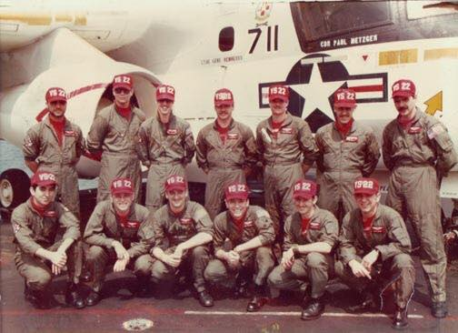
Checkmate AWs 1983 in the Eastern Med.
Back Row L - R
Ed "Papi" Tilley, Steve "Motorcyle" Stewart, Jeff "Beaker" Greenfield, Kim "Decibel" Morgan, Fred "Phast Phred" Thomas, Joe "Giuseppe" Girone, Stuart "Wart" Hall
Front Row L - R
David "Taco" Ortega, Steve "Puker" Hyatt, Daryl "Gonzo" Morrow, David "Roman" Polanco, Steve Whyte, Chief Kelly Moore

